21.3: The mass is primarily protons and neutrons of 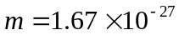 kg, so:
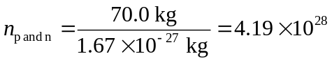
About one-half are protons, so 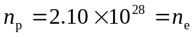 and the charge on the electrons is given by:

